CHAPTER 1 INTRODUCTION

Background
The rapid advancement of artificial intelligence and computer vision technologies has significantly transformed the way wildlife monitoring and conservation systems are developed and deployed. Traditional forest surveillance methods rely heavily on manual patrolling and basic camera traps, which are often inefficient, time-consuming, and incapable of providing real-time responses. With the increasing threat of illegal poaching and habitat destruction, there is a critical need for intelligent systems that can continuously monitor forest environments and detect suspicious activities accurately.
Conventional monitoring approaches lack automation and depend on human observation, which introduces delays, errors, and limited coverage in vast forest areas. These limitations make it difficult for authorities to respond promptly to poaching incidents, resulting in severe threats to endangered species and biodiversity. Moreover, the absence of real-time alert mechanisms further reduces the effectiveness of traditional surveillance systems.
To address these challenges, modern systems are increasingly integrating artificial intelligence and deep learning techniques to automate wildlife monitoring. Object detection models such as YOLOv8 enable fast and accurate identification of humans and animals from images and video streams. These models can process real-time data from surveillance cameras and provide immediate insights into activities occurring within protected areas. The proposed system focuses on developing an AI-based anti-poaching detection solution that automates the identification of unauthorized human presence in forest regions. The system utilizes deep learning for object detection, combined with a web-based interface for monitoring and control. It supports real-time video analysis, image processing, and automated alert generation, ensuring quick response to potential threats.
Unlike traditional methods, this system reduces reliance on manual intervention by providing continuous monitoring and intelligent decision-making capabilities. When suspicious activity is detected, the system generates instant alerts and stores relevant data for further analysis. This improves operational efficiency, minimizes response time, and enhances the overall effectiveness of wildlife protection efforts.
Furthermore, the integration of modern web technologies and scalable backend systems ensures that the solution can be deployed across multiple locations with minimal infrastructure requirements. By combining artificial intelligence, real-time processing, and automated alert mechanisms, this project contributes to the development of smart conservation systems aimed at protecting wildlife and preventing illegal poaching activities.

Problem Statement
Wildlife conservation efforts face significant challenges due to the increasing rate of illegal poaching and the limitations of traditional forest monitoring systems. Forest surveillance must support continuous monitoring, real-time detection, and rapid response mechanisms while maintaining high levels of accuracy and reliability. Existing methods such as manual patrolling and basic camera traps are insufficient for handling large forest areas and detecting suspicious activities promptly.
In many wildlife protection environments, monitoring systems are only partially automated and rely heavily on human intervention. Surveillance footage is often reviewed manually, which leads to delays in identifying threats and responding to poaching incidents. Critical detection processes such as identifying unauthorized human presence, distinguishing between animals and humans, and analysing behavioural patterns are either inefficient or not implemented at all. As a result, poachers can exploit these gaps to carry out illegal activities without being detected in time.
A major concern is the lack of real-time intelligent detection in existing systems. Without automated analysis, video feeds from forest cameras remain underutilized, serving only as passive recording tools rather than active monitoring solutions. This leads to missed opportunities for early intervention and increases the risk of wildlife loss. Additionally, traditional systems do not provide instant alert mechanisms, making it difficult for authorities to take immediate action when a threat is identified.
Another critical issue is the absence of robust and scalable detection models. Many systems fail to accurately classify objects in complex forest environments where lighting conditions, weather changes, and dense vegetation can affect visibility. Advanced object detection models such as YOLOv8 can address these challenges, but they are not widely implemented in practical conservation systems due to lack of integration and technical complexity.
Furthermore, existing solutions often lack centralized monitoring and data management capabilities. There is limited support for storing detection logs, analyzing historical data, and generating actionable insights. This reduces the effectiveness of long-term conservation strategies and makes it difficult to track patterns of illegal activities.
Therefore, there is a strong need for an intelligent, automated, and real-time anti-poaching detection system that integrates advanced deep learning models with a user-friendly monitoring interface. The system must ensure accurate detection, instant alert generation, and efficient data handling while being scalable and practical for deployment in real-world forest environments. By addressing these challenges, the proposed solution aims to enhance wildlife protection efforts and significantly reduce the impact of illegal poaching activities.
1.3 Objectives of the Project
The primary objective of this project is to design and develop an intelligent and automated anti-poaching detection system using artificial intelligence, ensuring accurate, real-time monitoring of forest environments and rapid response to illegal activities. In wildlife conservation, where delayed detection can result in irreversible damage to biodiversity, it is essential to implement reliable and efficient monitoring systems. The specific objectives of the project are: The objective of the proposed system is to develop an automated wildlife monitoring solution that continuously analyzes images and video streams to detect the presence of humans and animals in forest areas. The system implements a deep learning-based object detection model using YOLOv8 to achieve accurate classification and real-time identification of objects. It enables continuous surveillance by integrating live camera feeds and video inputs, ensuring uninterrupted monitoring of protected regions. A user-friendly web-based interface is designed using modern frontend technologies to provide easy access, monitoring, and control of the system. Additionally, the system incorporates an automated alert mechanism that sends notifications, such as email alerts, whenever unauthorized human activity is detected in restricted zones. By automating detection and decision-making processes, it significantly reduces manual monitoring efforts and minimizes human errors. The system also maintains structured logs or databases to store detection results, images, and activity records for future analysis and reporting. Furthermore, it is designed to be scalable, allowing deployment across multiple forest locations with minimal infrastructure requirements, ultimately improving the efficiency, accuracy, and responsiveness of wildlife protection systems through artificial intelligence and real-time processing.

CHAPTER 2 LITERATURE REVIEW

Introduction
The rapid advancement of artificial intelligence and computer vision technologies has significantly influenced the development of modern wildlife monitoring and conservation systems. Intelligent surveillance solutions are increasingly being adopted to address challenges such as illegal poaching, habitat destruction, and limited monitoring capabilities in large forest areas. These systems leverage deep learning techniques to automate the detection and classification of objects, enabling faster and more accurate analysis compared to traditional manual methods.
A literature review plays a vital role in understanding the current research landscape in this domain. It provides a structured evaluation of existing studies related to wildlife monitoring systems, object detection models, real-time surveillance, and AI-based conservation techniques. By analysing previous research, it becomes possible to identify key developments, common challenges, and gaps in current solutions. In the context of this project, the review focuses on the application of deep learning models for detecting humans and animals in forest environments, with particular emphasis on real-time detection and automated alert systems.
Recent studies highlight that traditional monitoring methods, such as manual patrolling and camera traps, are insufficient for preventing poaching due to delayed response times and limited coverage. Research in computer vision demonstrates that models like YOLOv8 provide high accuracy and speed in object detection tasks, making them suitable for real-time surveillance applications. However, existing systems often face challenges such as environmental variability, data limitations, and lack of integration with user-friendly monitoring platforms.
Furthermore, current research emphasizes the importance of combining AI models with practical deployment frameworks, including web-based interfaces and automated alert mechanisms. This integration ensures that detection results are not only accurate but also actionable in real-world scenarios. Despite these advancements, there remains a need for cost-effective, scalable, and easy-to-deploy solutions that can bridge the gap between theoretical research and field implementation.
This project builds upon existing studies by integrating deep learning-based detection with a real-time monitoring system, aiming to enhance the effectiveness of wildlife protection and contribute to the ongoing efforts in combating illegal poaching.

Review of Existing Systems and Research Papers

Paper 1 — AI-Based Wildlife Monitoring System using Deep Learning Techniques - Liu

et al. (2025)

This paper proposes an AI-driven wildlife monitoring system using deep learning models such as YOLOv8 for detecting animals and human intrusions in forest environments. The system integrates real-time video processing with automated alert mechanisms and demonstrates improved detection accuracy and faster response compared to traditional methods.

Limitation: Relies on high-end hardware and large datasets, making it less suitable for low-resource or academic-level implementations.

Paper 2 — Automation in Surveillance Systems using Computer Vision - Shahin et al.

(2024)

M. Shahin and colleagues reviewed CI/CD practices, highlighting automation as a key factor in improving software quality and reducing development time. The study shows how continuous integration and deployment enhance system reliability and efficiency. Limitation: Mostly theoretical and lacks practical implementation details, especially for security-integration.

Paper 3 — Efficient Wildlife Monitoring through AI-Driven Detection Systems – Zhang

et al. (2022)

This paper explores the use of AI-based surveillance systems for wildlife monitoring, demonstrating how deep learning models like YOLOv8 improve detection accuracy and enable real-time tracking of animals and human activities. The study highlights that automation enhances monitoring efficiency and reduces reliance on manual observation.

Limitation: Focuses mainly on detection performance and operational efficiency, with

limited emphasis on alert systems, security, or real-world deployment challenges.

Paper 4 — Performance Analysis of Object Detection Models in Surveillance - Singh et

al. (2024)

This paper analyzes AI-based object detection systems for surveillance applications and highlights the effectiveness of models like YOLOv8 in identifying humans and animals. The study shows that real-time detection and automation significantly improve monitoring efficiency and system reliability in wildlife protection scenarios.

Limitation: Focuses mainly on detection accuracy and performance, with limited discussion on alert mechanisms, system integration, or deployment in real-world forest environments.

Paper 5 — Reliable AI-Based Monitoring Systems for Continuous Wildlife Surveillance

- Kumar et al. (2025)

This research focuses on improving the reliability of wildlife monitoring systems using AI and automated surveillance techniques. It highlights how models like YOLOv8 combined with continuous video processing can enhance system availability and ensure uninterrupted monitoring in forest environments.

Limitation: Emphasizes system reliability and continuous operation, but gives limited attention to alert mechanisms, security aspects, or practical deployment challenges in real-world conditions.

Paper 6 — Early Detection of Human Intrusion using AI in Forest Environments – Ahmed

et al. (2025)

This paper discusses the integration of artificial intelligence in wildlife conservation systems, emphasizing the importance of incorporating real-time detection early in the monitoring process. It highlights how models like YOLOv8 can be effectively used for early identification of human intrusion, improving the chances of preventing poaching activities.

Limitation: Provides conceptual insights into AI-based monitoring but lacks detailed guidance on practical implementation, system integration, and deployment in real-world forest environments.

Paper 7 — User-Centric Design and Adoption of AI Monitoring Systems - Hansen et al.

(2022)

This study examines how AI-based wildlife monitoring systems often overlook real-time alert mechanisms and user-centric design, emphasizing the need for automated detection and response to improve practical adoption. It highlights the importance of integrating models like YOLOv8 with efficient monitoring systems.

Limitation: Focuses more on system adoption and usability aspects rather than detailed

technical implementation

Paper 8 — Secure AI-Based Surveillance Systems for Data Integrity & Reliability –

Garcia et al. (2023)

This paper introduces a secure wildlife monitoring framework that ensures data integrity and reliable detection using AI-based models such as YOLOv8. The system focuses on preventing tampering of detection results and maintaining trustworthy monitoring outputs in surveillance environments.

Limitation: Requires advanced hardware and specialized infrastructure, making it less practical for academic or low-resource implementations.

Paper 9 — Real-Time Detection and Alert Systems in Intelligent Surveillance - Patel et al.

(2023)

The authors propose integrating real-time object detection and automated alert systems within AI-based surveillance frameworks using models like YOLOv8. The approach improves detection speed and enables faster response to suspicious activities in monitored environments.

Limitation: Relies on advanced configurations and computational resources, limiting accessibility for small-scale or academic projects.

Paper 10 — Automation in AI Surveillance Systems for Improved Detection Consistency

- Lee et al. (2024)

This study compares manual wildlife monitoring with AI-based automated surveillance systems and shows that automation using models like YOLOv8 improves consistency and reduces human error. The results highlight better accuracy and faster response in identifying human intrusion.

Limitation: Focuses mainly on detection efficiency rather than alert mechanisms, security aspects, or real-world deployment challenges.

Detection Stage Vulnerabilities
The detection stage of an AI-based anti-poaching system is a critical point where input data such as images, video streams, and live camera feeds are processed and analysed for identifying humans and animals. This stage is highly sensitive because the accuracy of detection directly affects decision-making, alert generation, and overall system reliability in wildlife protection.
Research indicates that vulnerabilities at this stage can significantly impact system performance without altering the core application. Factors such as poor-quality input data, environmental conditions (lighting, weather, dense vegetation), and model limitations can lead to incorrect detections, including false positives or missed threats. If the detection model, such as YOLOv8, is trained on insufficient or biased datasets, it may fail to accurately distinguish between humans and animals, reducing the effectiveness of the system.
Another major risk is the lack of proper validation of detection outputs. Since the system relies on automated decisions, incorrect predictions may trigger false alerts or fail to notify authorities during actual poaching incidents. Additionally, unauthorized modification of model files or configurations can compromise detection integrity, leading to unreliable results.
To address these risks, it is essential to implement validation techniques such as model accuracy evaluation, dataset quality improvement, and controlled access to system components. Regular model updates and testing under different environmental conditions can further enhance reliability. Securing and optimizing the detection stage is therefore crucial for ensuring accurate monitoring, minimizing false alerts, and improving the effectiveness of anti-poaching efforts.

Comparative Analysis of Existing Systems
Table 2.1 compares the surveyed studies based on year, key findings, advantages, and limitations in the domain of AI-based wildlife monitoring and anti-poaching detection systems. The analysis highlights that most existing research focuses primarily on improving object detection accuracy and real-time performance using models such as YOLOv8. Many studies demonstrate the effectiveness of deep learning in identifying humans and animals, along with improvements in automation and monitoring efficiency.

Table 1: Comparative Analysis of Existing Systems

Year | Author(s) | Key Findings | Advantages | Limitations
2025 | Liu et al. | AI-based wildlife monitoring using YOLOv8 improves detection accuracy. | Real-time monitoring; improved efficiency. | Requires high-end hardware and large datasets.
2024 | Zhang et al. | Early studies on computer vision in surveillance systems. | Strong academic foundation. | Limited real-time and AI advancements.
2022 | Kumar et al. | Automated surveillance reduces manual monitoring efforts. | Improves efficiency and coverage. | Less focus on alerting
2024 | Singh et al. | Real-time object detection enhances wildlife monitoring. | High detection accuracy. | Limited system design
2025 | Ahmed et al. | AI improves early detection of human intrusion in forests. | Faster response | Lacks practical  Deployment models.

Year | Author(s) | Key Findings | Advantages | Limitations
2025 | Patel et al. | Integration of detection with alert systems improves response time. | Automated alerts;  real-time response. | Requires complex config
2025 | Williams et al. | Comparison of multiple  detection models | Practical  Performance  evaluation. | No single model solves all challenges.
2022 | Hansen et al. | Highlights need for usability in AI monitoring systems. | Focus on user  adoption. | Limited technical implementation detail.
2023 | Garcia et al. | Secure monitoring systems ensure data integrity. | Reliable output | Requires advanced hardware setup.
2023 | Rao & Kumar | Cloud-based AI monitoring improves scalability. | High availability  and scalability. | Cloud dependency.
2024 | Lee et al. | Automation improves detection consistency. | Reduces human  error. | Limited focus on alerts
2023 | Chen et al. | Continuous monitoring  improves reliability. | Emphasizes system  stability. | Limited focus on real  world deployment.
2025 | Sharma & Das | Identified risks in  AI monitoring such  a false detection. | Depth analysis. | Lacks practical solution.

CHAPTER 3 PROPOSED SYSTEM

Problem Definition
The problem addressed by this project is the lack of an effective and automated system for real-time detection of illegal poaching activities in forest environments. Existing wildlife monitoring methods rely heavily on manual surveillance and basic camera systems, which are slow, inconsistent, and unable to provide immediate response. These traditional approaches often fail to detect unauthorized human presence in time, allowing poaching activities to occur undetected. A major challenge lies in the absence of intelligent detection mechanisms that can accurately distinguish between humans and animals in complex forest conditions. Without automated analysis, surveillance systems act only as passive recording tools, offering limited support for decision-making. Additionally, many existing solutions do not include real-time alert systems, making it difficult for authorities to take prompt action. The project therefore aims to design an end-to-end AI-based monitoring system that automates detection, analysis, and alert generation using models like YOLOv8. The system integrates real-time video processing, a web-based monitoring interface, and automated notifications, ensuring that every detection event triggers appropriate action. By combining accuracy, automation, and accessibility, the proposed solution addresses the critical gaps in current wildlife protection systems.

Existing System
In traditional wildlife monitoring systems, surveillance is largely performed using manual or semi-automated methods. Forest officials rely on physical patrolling and basic camera traps to observe animal movements and detect illegal activities. Data collected from cameras is often reviewed manually or after significant delays, making the process slow, inefficient, and highly dependent on human effort. While this approach may work for small areas, it becomes ineffective for large forest regions that require continuous and real-time monitoring. Even in systems where some level of automation is introduced, it is often limited to basic video recording or motion detection. Critical processes such as intelligent object identification, real-time analysis, and automated alert generation are either missing or minimally implemented. As a result, these systems appear modern but still rely heavily on manual observation and decision-making. Additionally, monitoring decisions are often influenced by human limitations such as fatigue, delayed response, or lack of coordination. Different personnel may follow inconsistent procedures while analysing surveillance data, leading to unreliable detection and missed threats. Without standardized and automated processes, it becomes difficult to ensure accurate and timely identification of poaching activities. These limitations highlight the need for a fully automated and intelligent monitoring system that can continuously analyse data, detect suspicious activities, and provide consistent and reliable outputs without heavy dependence on manual intervention.

Limitations of Existing System
Despite being widely used, existing wildlife monitoring systems exhibit several critical limitations that affect reliability, accuracy, and overall effectiveness in preventing poaching activities. The existing systems for wildlife monitoring suffer from several limitations that reduce their effectiveness in preventing poaching activities. They rely heavily on manual intervention, where continuous human monitoring of camera feeds is time-consuming and prone to errors, often leading to missed detections and delayed responses. Most traditional systems lack intelligent detection mechanisms and depend only on basic motion detection or recording, without the ability to accurately distinguish between humans and animals. Additionally, the absence of real-time alert systems further delays response time, making it difficult for authorities to act promptly. Detection accuracy is also affected by challenging environmental conditions such as low lighting, adverse weather, and dense vegetation. Monitoring coverage remains inconsistent due to the vastness of forest areas and limited resources. Furthermore, poor data management and lack of proper logging reduce traceability and make it difficult to analyze past events or identify patterns of illegal activity. Overall, these limitations make existing systems unsuitable for critical wildlife conservation needs, where real-time detection and rapid response are essential to effectively prevent poaching.

Proposed System Overview
The proposed system introduces an AI-based anti-poaching detection solution for real-time wildlife monitoring. It uses YOLOv8 to detect humans and animals from live video feeds, images, and recorded footage. The system processes data through stages such as input capture, detection, and alert generation. A web-based dashboard allows users to monitor live streams and detection results. When unauthorized human presence is detected, the system automatically sends alerts and stores event data. This automated approach ensures continuous monitoring, reduces manual effort, and improves response time for preventing poaching activities. Additionally, the system enhances surveillance accuracy by minimizing false detections through trained deep learning models. It also supports scalable deployment across multiple camera feeds, making it suitable for large forest monitoring environments.
The proposed system is designed as an intelligent, scalable, and efficient solution for wildlife protection by leveraging advanced artificial intelligence and real-time processing techniques. It integrates deep learning with computer vision to continuously monitor forest environments and accurately identify potential threats such as unauthorized human intrusion. By utilizing YOLOv8, the system ensures high-speed and precise detection even in dynamic and complex outdoor conditions. The application supports multiple input sources, including live CCTV streams, IP cameras, and recorded media, making it adaptable to various deployment scenarios. The inclusion of an automated alert mechanism significantly enhances responsiveness, allowing authorities to take immediate action when suspicious activities are detected. Furthermore, the system maintains detailed logs of all detection events, enabling long-term analysis, reporting, and decision-making for conservation efforts. Its modular architecture allows easy integration of additional features such as cloud storage, multi-location monitoring, and advanced analytics. Overall, the system provides a reliable, cost-effective, and technologically advanced approach to strengthen anti-poaching initiatives and improve the overall efficiency of wildlife surveillance systems.

Advantages of Proposed System
The proposed system offers several advantages by introducing automation-driven monitoring, which reduces the need for manual surveillance and minimizes human errors through continuous video analysis. It provides accurate real-time detection using YOLOv8 to efficiently identify humans and animals, along with instant alert generation that notifies authorities when unauthorized human presence is detected, enabling faster response. The system ensures consistent and uninterrupted surveillance without fatigue, while improving detection reliability by reducing false positives through trained models. A centralized web-based dashboard allows easy monitoring of live feeds and detection results, and data logging ensures proper traceability by storing events with timestamps for analysis. Additionally, the system is scalable and flexible for deployment across multiple locations, cost-effective due to the use of accessible technologies, and significantly contributes to wildlife conservation by enabling timely detection and prevention of poaching activities. The Anti-Poaching Detection System provides automated, real-time wildlife monitoring using YOLOv8, reducing manual surveillance and human errors. It enables instant alerts on detecting unauthorized human presence, ensuring faster response and improved forest protection. The system supports continuous monitoring, reliable detection, and centralized dashboard access for easy tracking. It is scalable, cost-effective, and suitable for both academic use and real-world deployment.
The proposed Anti-Poaching Detection System delivers a robust and intelligent approach to wildlife surveillance by combining real-time video processing with advanced deep learning techniques. It significantly reduces dependence on manual monitoring by automating the detection of humans and animals using YOLOv8, ensuring faster and more accurate identification of potential threats. The system’s ability to generate instant alerts allows authorities to respond promptly, minimizing the risk of poaching incidents. Continuous monitoring ensures that forest areas are observed without interruption, while the use of trained models enhances detection accuracy even in challenging environmental conditions. The integration of a centralized dashboard simplifies monitoring and management, providing users with real-time insights and easy access to detection data. Furthermore, the system maintains detailed logs for analysis and reporting, supports scalability across multiple locations, and remains cost-effective due to its use of accessible technologies. Overall, it strengthens wildlife protection efforts by improving efficiency, responsiveness, and reliability in anti-poaching operations

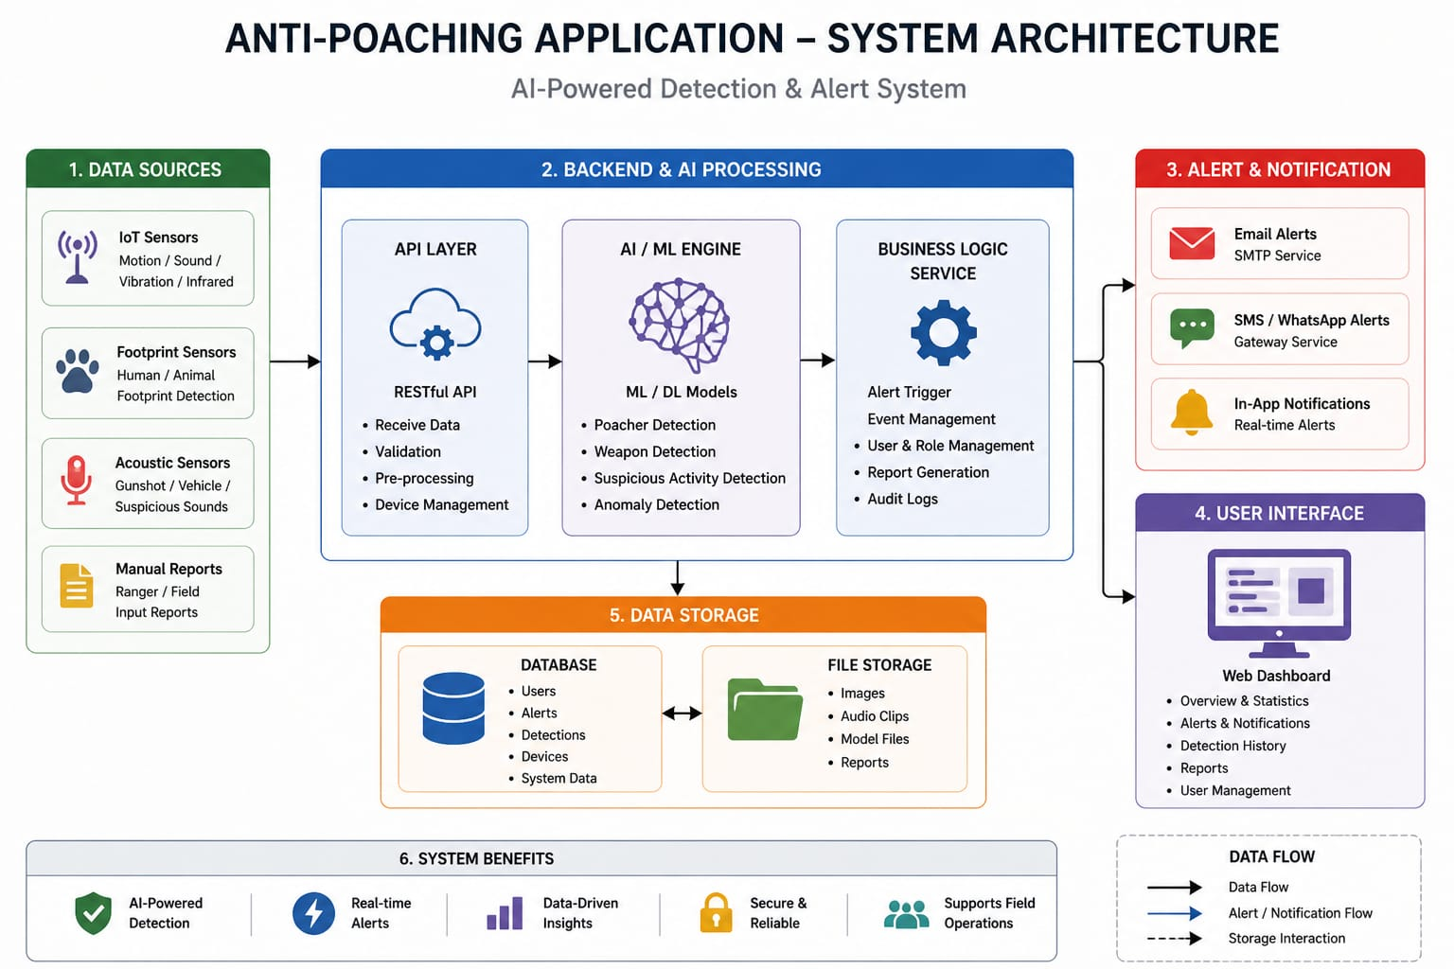
System Architecture

Fig 1: Overall System Architecture of Proposed System

- Data Sources Layer
The data sources layer serves as the entry point of the system, responsible for collecting raw environmental and field data. It integrates multiple input channels such as IoT sensors, acoustic sensors, footprint detection systems, and manual reports submitted by forest officials. These sources capture critical information related to movement, sound patterns, and suspicious activities in protected areas. The collected data is transmitted to the backend system for further processing, forming the foundation for intelligent detection and analysis.

- Backend & Processing Layer
The backend and processing layer acts as the core computational unit of the system, handling data ingestion, processing, and decision-making. Incoming data is received through a RESTful API layer, which performs validation, preprocessing, and device management. This data is then passed to the AI/ML engine, where deep learning models analyze it to detect poachers, weapons, or abnormal behavior. The processed results are managed by the business logic service, which handles alert triggering, user management, report generation, and system operations.]

- Alert & Notification Layer
The alert and notification layer is responsible for delivering real-time warnings when potential threats are detected. Once the backend identifies suspicious activity, this layer ensures that alerts are communicated through multiple channels such as email, SMS/WhatsApp, and in-application notifications. This multi-channel approach guarantees that relevant authorities receive timely updates, enabling rapid response to critical situations and improving the effectiveness of anti-poaching operations.

- Data Storage Layer
The data storage layer manages both structured and unstructured data generated by the system. A centralized database stores structured information such as user details, alerts, detection logs, and system data, ensuring efficient querying and management. In parallel, a file storage system handles unstructured data including images, audio clips, model files, and generated reports. This separation enhances scalability, performance, and reliability while supporting long-term data retention and analysis.

- User Interface Layer
The user interface layer provides a centralized platform for administrators and forest officers to interact with the system. It is typically implemented as a web-based dashboard that allows users to monitor alerts, review detection history, access analytical reports, and manage users. The interface is designed to present information in a clear and actionable format, enabling efficient decision-making and system control without requiring technical expertise.

- Monitoring & Logging Layer
The monitoring and logging layer ensures the reliability, performance, and transparency of the system. It continuously tracks application health, API performance, and resource utilization to detect any anomalies or failures. Additionally, it maintains detailed logs, including application logs, error logs, and audit trails, which are essential for debugging, security analysis, and compliance. Alerting mechanisms within this layer notify administrators of system issues, ensuring timely maintenance and uninterrupted operation

Data Flow Diagram (DFD)

Level 0 DFD
At the highest level, the system consists of three primary entities: the data sources, the processing system, and the end users. The data sources include IoT sensors, acoustic devices, footprint sensors, and manual reports submitted by field officers. These sources continuously generate raw environmental and situational data.

3.5.2 Level 1 DFD

The system begins with the collection of data from sensors and manual field reports, which is then transmitted to the backend through an API layer. Upon arrival, the data undergoes validation and preprocessing to ensure accuracy and consistency before being analyzed using AI/ML models to detect suspicious activities. Based on the detection results, alerts are generated and relevant information is stored in both database and file storage systems. These alerts are then delivered to users through multiple communication channels, and finally, users interact with the system via a web-based dashboard to view alerts and reports, enabling timely monitoring and response .

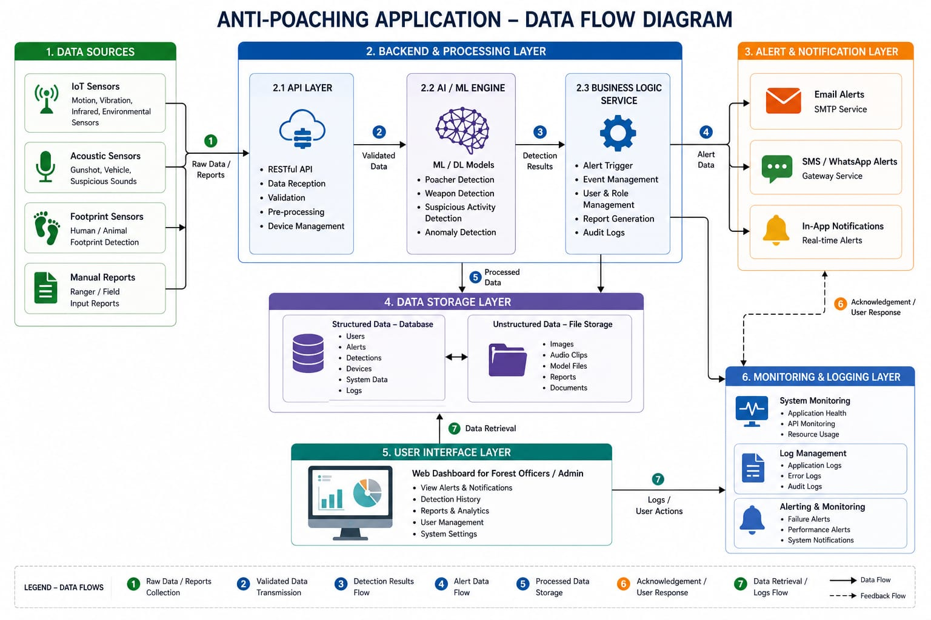

Fig 2: Data Flow Diagram of Proposed System

Methodology
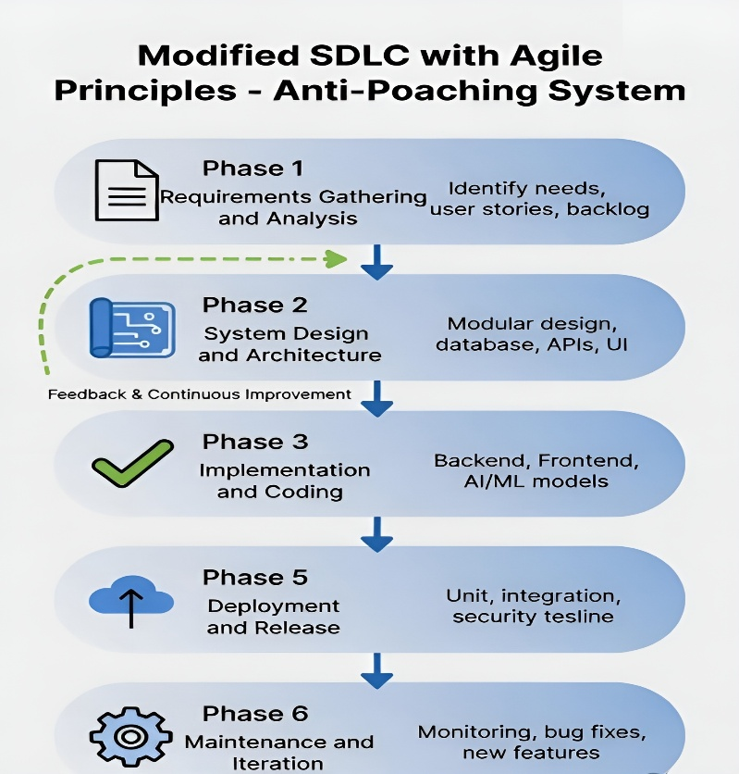

Fig 3: Software Development Life Cycle of Proposed System
    - Software Development Life Cycle (SDLC)
The project followed a modified Software Development Life Cycle (SDLC) integrated with Agile principles, enabling iterative development and continuous improvement. The system was developed across six major phases:
Phase 1 — Requirements Gathering and Analysis: Requirements for the anti-poaching system were identified by analyzing existing wildlife protection methods. Functional and non-functional requirements were defined, including detection, alerting, and system reliability. These were converted into user stories and organized into a backlog. This phase ensured a clear understanding of system needs.
Phase 2 — System Design and Architecture: A modular system architecture was designed, including data sources, backend, AI/ML, alerts, and UI layers. The database schema and API endpoints were defined for smooth communication. The structure of the web dashboard was also planned. This phase established the technical blueprint of the system.
Phase 3 — Implementation and Coding: System components were developed based on the design specifications. The backend handled APIs and AI integration, while the frontend provided a user dashboard. Machine learning models were used for threat detection. Proper coding standards ensured performance and maintainability.
Phase 4 — Testing and Quality Assurance: Testing was conducted to ensure system accuracy, reliability, and security. Unit and integration tests validated component functionality and interaction. Error handling and data validation were thoroughly checked. This phase ensured the system met all requirements before deployment.
Phase 5 — Deployment and Release: The system was containerized using Docker for consistent deployment. Backend, frontend, and database services were configured and hosted. Necessary settings for APIs and alerts were applied. After validation, the system was released for operational use.
Phase 6 — Maintenance and Iteration: Post-deployment, the system was continuously monitored and improved. Logs and user feedback were analyzed to identify issues. Bugs were fixed, and performance was optimized. New features were added based on evolving requirements.

    - Algorithms Used

Algorithm 1: AI-Based Detection Algorithm (YOLO-based Detection)

BEGIN
INPUT processed_data
LOAD trained AI model
DETECT objects in data
FOR each detected object DO
CALCULATE confidence score
IF object == "poacher" OR "weapon" AND confidence > threshold THEN
MARK as threat
ELSE
IGNORE
END IF
END FOR
RETURN detection_results
END

This is the core algorithm responsible for detecting poachers, weapons, or suspicious activities
using deep learning (YOLO). It processes images/audio and identifies objects with confidence
scores

Algorithm 2: Threat Decision Algorithm

BEGIN
INPUT detection_results
FOR each result DO
IF confidence >= threshold THEN
SET threat_status = TRUE
ELSE
SET threat_status = FALSE
END IF
END FOR
RETURN threat_status
END

This algorithm decides whether a detection should trigger an alert. It filters false positives and ensures only high-confidence threats are acted upon.

Algorithm 3: Alert Generation Algorithm

BEGIN
INPUT threat_status
IF threat_status == TRUE THEN
CREATE alert_message
STORE alert_in_database
SEND alert to notification module
END IF
END

Once a threat is confirmed, this algorithm generates alerts and prepares notification messages for users.

Algorithm 4: Notification Delivery Algorithm

BEGIN
INPUT alert_message
FOR each user in user_list DO
IF user preference == email THEN
SEND email
ELSE IF preference == SMS THEN
SEND SMS
ELSE
SEND app notification
END IF
END FOR
END
This algorithm ensures alerts reach users through multiple channels such as email, notifications.

Module Description
    - Data Acquisition Module
The Data Acquisition Module is responsible for collecting raw input data from various sources deployed in the field. These sources include IoT sensors, acoustic sensors, footprint detection systems, and manual inputs provided by forest officers. The module ensures that data from heterogeneous sources is captured in a consistent and structured manner. This module handles different types of data such as motion signals, sound recordings, vibration data, and textual reports. Since the data originates from remote environments, the module is designed to support continuous and reliable data transmission. It also ensures that the collected data is timestamped and tagged appropriately for further processing.
    - API & Data Processing Module
The API and Data Processing Module acts as the gateway between the data sources and the backend system. It is responsible for receiving incoming data through RESTful APIs and ensuring that the data is properly validated, formatted, and preprocessed before being forwarded for analysis. This module performs essential operations such as input validation, error handling, data normalization, and device management. It ensures that invalid or corrupted data does not enter the system, thereby maintaining data integrity.
    - AI/ML Detection Module
The AI/ML Detection Module is the core intelligence unit of the system, responsible for analyzing incoming data and identifying potential threats. This module utilizes machine learning and deep learning models to detect suspicious activities such as poaching, weapon usage, or abnormal movement patterns. The models are trained using relevant datasets to recognize patterns associated with illegal activities. Once the data is processed, the module classifies events and assigns confidence levels to detections.
    - Business Logic Module
The Business Logic Module is responsible for implementing the core operational rules and decision-making processes of the system. It receives the output from the AI/ML module and determines the appropriate actions based on predefined logic. This module handles functionalities such as alert triggering, event management, user role management, and report generation. It ensures that all system operations follow a consistent and well-defined workflow.
    - Alert & Notification Module
The Alert and Notification Module is responsible for delivering real-time alerts to the concerned authorities whenever a potential threat is detected. It ensures that critical information is communicated quickly and effectively through multiple channels. The module supports various notification methods, including email alerts, SMS or WhatsApp messages, and in-application notifications. This multi-channel approach ensures that alerts are received even in challenging communication conditions.
    - Data Storage Module
The Data Storage Module is responsible for managing all data generated by the system. It is designed to handle both structured and unstructured data efficiently. Structured data, such as user details, alerts, detection logs, and system information, is stored in a relational database. This enables efficient querying and data management. Unstructured data, including images, audio files, and reports, is stored in a separate file storage system.
    - User Interface Module
The User Interface Module provides a platform for users to interact with the system. It is typically implemented as a web-based dashboard that offers a comprehensive view of system activities. Through this interface, users can view alerts, monitor detection history, access reports, and manage system settings. The dashboard presents information in a clear and user-friendly manner, enabling quick decision-making.
    - Monitoring & Logging Module
The Monitoring and Logging Module ensures the smooth operation and reliability of the system. It continuously tracks system performance, including application health, API activity, and resource utilization. This module maintains detailed logs of all system activities, including user actions, errors, and transactions. These logs are essential for debugging, performance analysis, and security auditing.
    - Integration & Communication Module

The Integration and Communication Module is responsible for enabling seamless interaction between different components of the system. It ensures that data flows efficiently between data sources, backend services, AI modules, and user interfaces. This module manages communication protocols, API interactions, and data exchange formats. It ensures interoperability between different technologies used in the system

CHAPTER 4

IMPLEMENTATION & RESULTS

Requirement Analysis
    - Hardware Requirements
The Anti-Poaching Detection System requires moderate hardware for real-time YOLOv8-based video processing. A basic system can be used for development, but better specifications are needed for training and smooth detection.
Minimum requirement is an Intel i3 processor with 8 GB RAM, while Intel i5 with 16 GB RAM is recommended. A GPU (NVIDIA GTX/RTX) is preferred for faster model performance. At least 50 GB storage (SSD preferred) is required. CCTV/IP camera is used as input, and edge devices like Raspberry Pi or Jetson Nano can be used for field deployment. A stable internet connection is needed for alerts and cloud features
Table 2: Hardware Requirements

Component | Minimum Requirement | Recommended
Processor | Intel i3 | Intel i5 or higher
GPU | Not required | NVIDIA GTX/RTX series
RAM | 8 GB | 16 GB or more
Storage | 50 GB HDD | 100 GB SSD
Camera | Webcam/IP camera | CCTV/IP camera
Internet | Basic | High-speed stable connection

Software Requirements
The Anti-Poaching Detection System uses Python as the main programming language along with YOLOv8 for object detection and OpenCV for video processing. The system runs on Windows, Linux, or macOS, with Linux preferred for deployment.
Git and GitHub are used for version control, and optional tools like Flask/FastAPI can be used for API integration. The system may use SQLite/PostgreSQL for data storage and Docker for deployment. VS Code or PyCharm is used as the development environment.

Table 3: Software Requirements

Category | Software / Tool
Operating System | Windows / Linux / macOS
Programming Language | Python
AI Model | YOLOv8 (Ultralytics)
Image Processing | OpenCV
Application | Kotlin, Python
Version Control | Git, GitHub
Database | SQLite / PostgreSQL
IDE | VS Code, PyCharm

Tools and Technologies Used
The Anti-Poaching Detection System is developed using modern AI, computer vision, and web technologies. It integrates YOLOv8 for real-time object detection, OpenCV for video processing, and Python for backend logic. GitHub is used for version control and model management, while optional deployment can be done using cloud or edge devices.

Table 4: Tools and Technologies Used

Category | Tool | Purpose
Version Control | Git + GitHub | Source code management
IDE | VS Code / PyCharm | Development environment
Programming Language | Python 3.11 | Core logic and AI processing
AI Model | YOLOv8 (Ultralytics) | Object detection (human/animal/weapon)
Image Processing | OpenCV | Video frame processing
Application | Kotlin, Python | Application interface
Database (optional) | SQLite / PostgreSQL | Data storage (logs/alerts)
Version Control Hosting | GitHub | Repository hosting
IDE Tools | Android Studio | Code development

Table 5: Functional Requirements

ID | Requirement
FR1 | Real-time animal/human detection using YOLOv8
FR2 | Detection of poaching activities in forest surveillance video
FR3 | Video input from CCTV/IP camera or uploaded files
FR4 | Alert generation when suspicious activity is detected
FR5 | Logging of detection results with timestamps
FR6 | Web-based dashboard for monitoring (optional)
FR7 | Model inference using trained dataset
FR8 | Real-time frame processing using OpenCV
FR9 | System supports image and video input
FR10 | Notification support (email/SMS optional)

Table 6: Non-Functional Requirements

Category | Requirement
Performance | Real-time detection with minimal delay
Accuracy | High detection accuracy using trained YOLO model
Reliability | Consistent performance during continuous monitoring
Scalability | Can handle multiple video streams
Usability | Simple and user-friendly interface
Maintainability | Modular and easy-to-update code structure
Security | Secure data handling and controlled access

System Implementation

4.3.1 Installation Instructions

This section provides a step-by-step guide for setting up and running the Anti-Poaching Detection System. The installation process includes preparing the development environment, installing required libraries, setting up the YOLOv8 model, configuring video input sources, and optionally deploying the system as a web-based monitoring application. The goal is to ensure smooth execution in local, edge-device, or cloud environments. The setup is divided into clear steps for easy implementation and testing.

4.3.1.1 Prerequisites

Before installing the system, all required tools and dependencies must be available. These prerequisites ensure proper functioning of the AI model, video processing, and optional web interface.

Required Software

The following software must be installed before proceeding:

Python(version3.8 or higher):
Python is required to run the detection system. It provides support for YOLOv8, OpenCV, and other required libraries for image processing and real-time detection.

Ultralytics YOLOv8:
Used as the core deep learning model for detecting humans, animals, and suspicious activities. It is installed via Python packages and used for both training and inference.

OpenCV:
Used for capturing and processing video streams from webcams, CCTV cameras, or video files. It handles frame extraction and real-time visualization.

NumPy:
Supports numerical operations required for image processing and model execution.

Git:
Used for version control and cloning the project repository from GitHub.

Verification of Installation
After installation, verify the setup by running the following commands in the terminal. Successful execution confirms proper installation:
python--version
pip--version
git –version

To verify YOLOv8 and OpenCV installation:

pip show ultralytics
pip show opencv-python

These steps ensure that the system is ready for running the Anti-Poaching Detection application successfully.

Application Implementation
The Anti-Poaching Detection System is implemented as an end-to-end AI-based application that integrates real-time video surveillance, deep learning-based object detection, and automated alert mechanisms. The application is structured into multiple functional layers, ensuring a smooth flow from data acquisition to decision-making and user interaction.
The implementation begins with the input acquisition layer, where video data is captured from CCTV cameras, IP cameras, or pre-recorded video files. OpenCV is used to continuously read frames from the input source and prepare them for processing. Each frame is then passed to the detection module, where the YOLOv8 model performs object detection to identify humans, animals, and other relevant entities. The model processes frames in real time and returns bounding boxes, class labels, and confidence scores.
Following detection, the processing and decision layer analyzes the results to determine whether a potential poaching activity is occurring. If a human is detected in restricted forest zones or during unusual conditions, the system flags it as suspicious. This triggers the alert generation module, which can send notifications through email or other communication channels and simultaneously log the event details such as timestamp, detection type, and captured image.
The application also includes a visualization layer, where processed video frames are displayed with annotated bounding boxes and labels, allowing users to visually monitor detection results. In the web-based implementation, this is extended to a dashboard interface built using frontend technologies, where users can view live streams, detection logs, and alert history in real time.
The system is designed with a modular architecture, enabling easy integration of additional features such as multi-camera support, cloud storage, and advanced analytics. Overall, the application implementation ensures continuous monitoring, automated detection, and rapid response capabilities, making it effective for real-world deployment in wildlife protection and anti-poaching

Working Model

Table 7: Role-Based Module Visibility

Role | Modules Visible | Representative Actions
Admin | Dashboard, Logs, System Settings | Monitor detections, manage system configuration, view logs
Forest Officer | Dashboard, Live Monitoring, Alerts | Monitor live feeds, respond to alerts, verify detections
Researcher | Dashboard, Reports, Data Logs | Analyze detection data, study animal patterns
System | Detection Engine, Alert System | Perform detection, generate alerts automatically

The Anti-Poaching Detection System operates as an AI-based monitoring application where the video input layer, detection engine, and user interface work together to provide real-time surveillance. When the system starts, it initializes the video input source (CCTV/IP camera or video file) and loads the trained YOLOv8 model for detection. The application continuously captures frames using OpenCV and processes them in real time. Each frame is passed to the detection engine, where YOLOv8 identifies objects such as humans and animals. The system then analyzes detection results to determine if any suspicious activity is present. If a human is detected in a restricted forest area, the system flags it as a potential poaching event. The processed frames are displayed through the visualization module, where bounding boxes and labels are drawn around detected objects. In the web-based version, this output is streamed to a dashboard interface, allowing users to monitor live feeds remotely. Once suspicious activity is identified, the alert module is triggered. The system generates notifications (such as email alerts) and logs the event details including timestamp, detected object type, and captured frame. These logs are stored for further analysis and reporting.
The overall workflow follows a continuous loop: video capture → frame processing → object detection → decision making → alert generation → data logging → visualization. This ensures uninterrupted monitoring of forest areas and quick response to potential threats. The modular design allows the system to scale across multiple cameras and locations. Additional features such as cloud storage, multi-user access, and advanced analytics can be integrated without affecting the core detection pipeline operations.

Execution Flow
When the system starts, it loads the YOLOv8 model and connects to a video source such as a CCTV camera or video file, then continuously captures frames using OpenCV and processes them for real-time object detection. If a human is detected in a restricted area, the system triggers an alert and logs the event with timestamp and image; otherwise, it continues monitoring without interruption.

. Results and Outputs

Figures 4.1 to 4.6 illustrate the end-to-end output of the implemented Anti-Poaching Detection System and its real-time monitoring application. Figure 4 shows the overall user interface of the application. Figure 5 presents the system processing live video input and capturing frames using OpenCV. Figure 6 displays that the selected video to ready to detect. Figure 7, 8 shows the detection of the unrestricted peoples in the browsed videos. Figure 9 illustrates the detection events with real time detetcion and stored images for analysis. Figure 10 shows the web-based Email Notification used for live monitoring and viewing detection outputs.

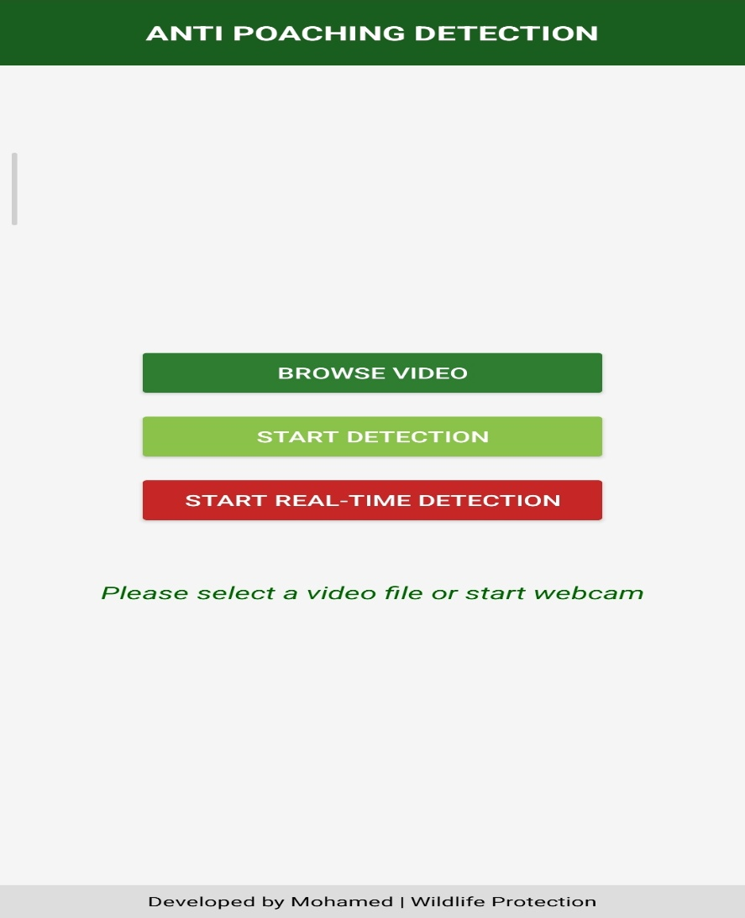

Fig 4 User Interface of the Application

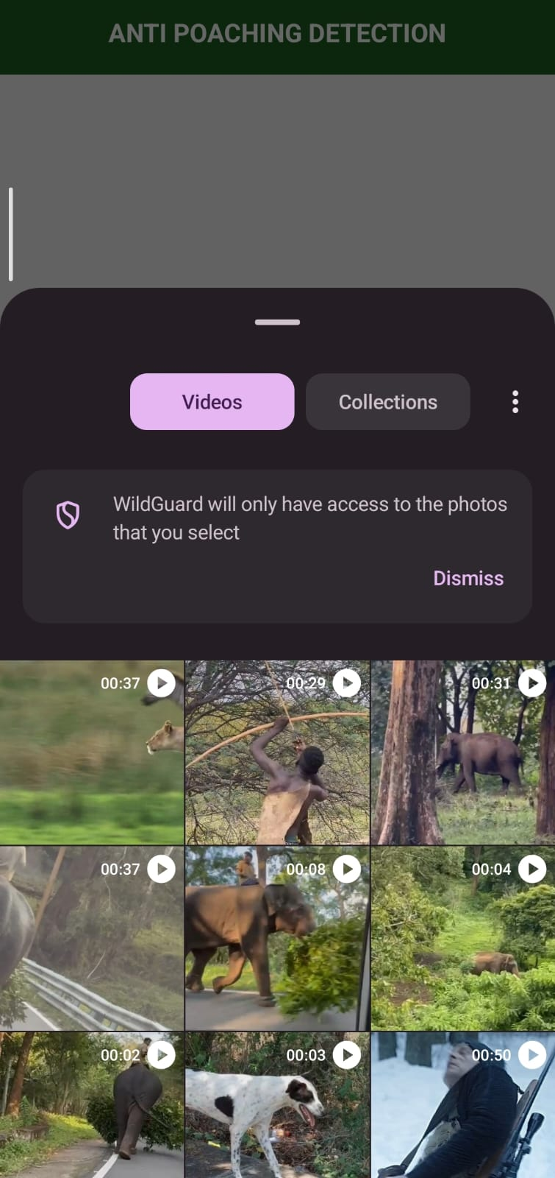
Fig 5 Selecting Videos from Storage
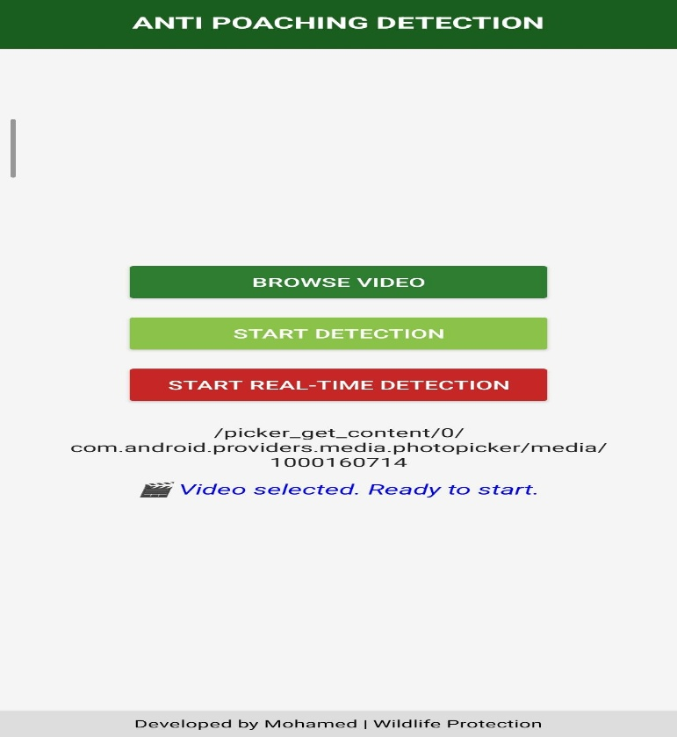

Fig 6 The Video has been selected
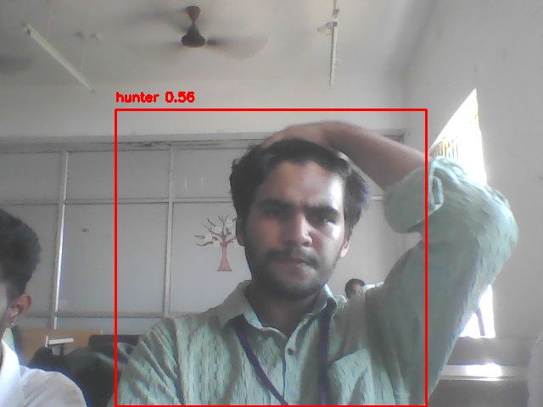
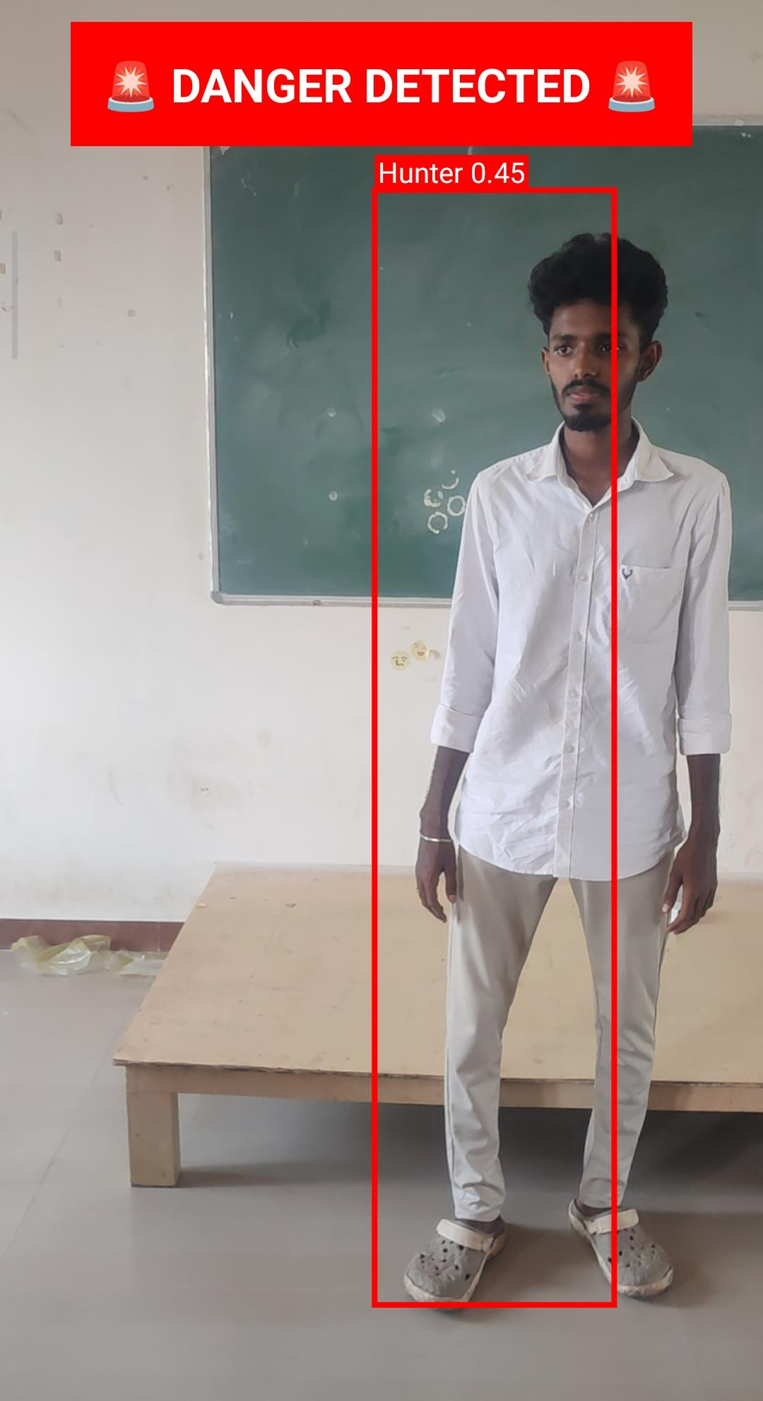
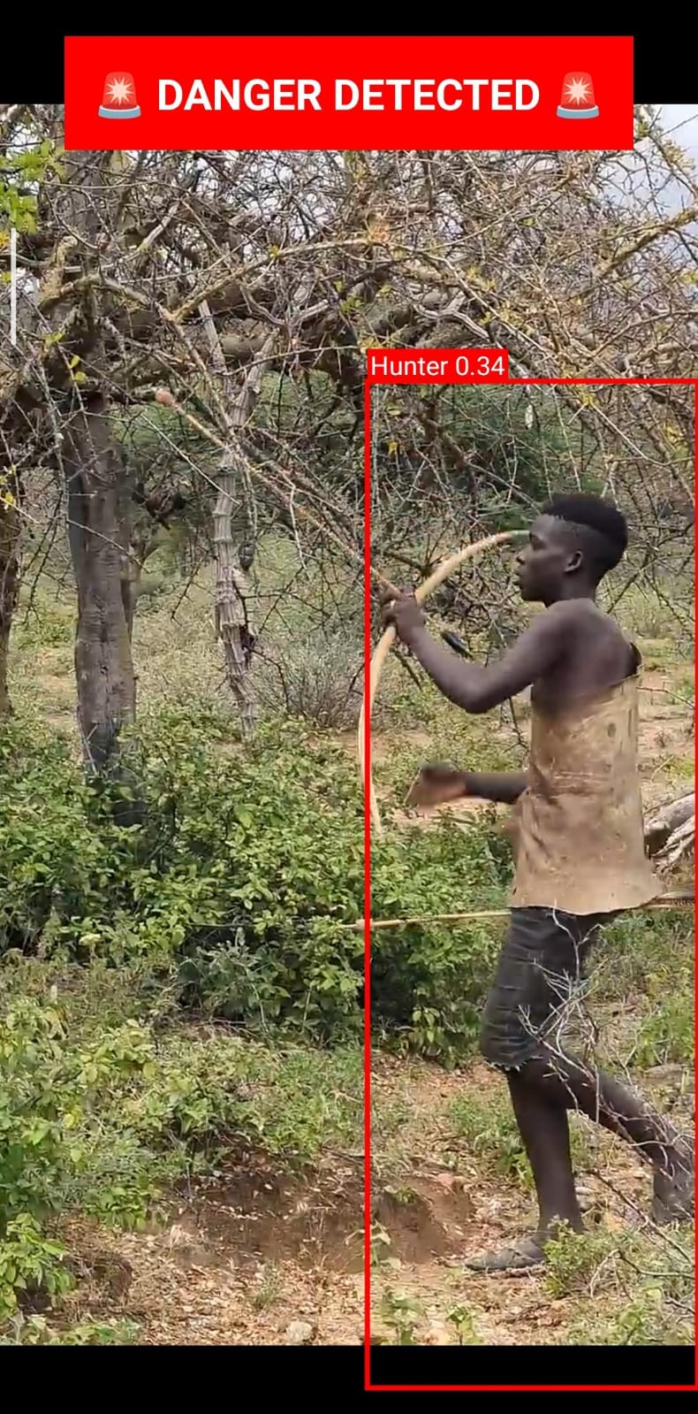

Fig 7, 8, 9 Detection of the Hunter/ Poacher

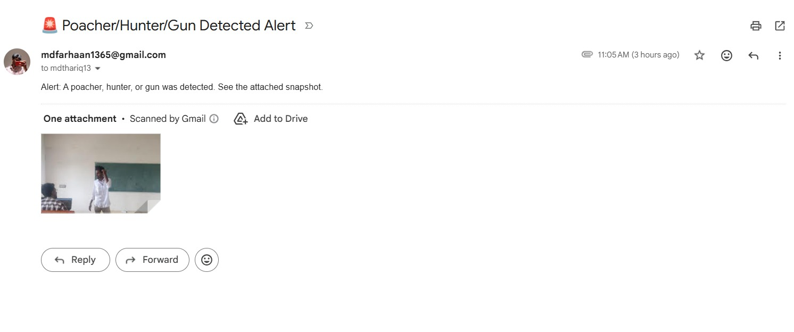

Fig 10 Shows the Mail Notification of the alert

Performance Analysis
    - Accuracy
The Anti-Poaching Detection System was tested across multiple scenarios using images, recorded videos, and live camera feeds. The YOLOv8 model accurately detected humans and animals with high precision under normal conditions. The system successfully identified unauthorized human presence in forest environments and triggered alerts as expected. Detection performance remained reliable across different scenarios such as varying object sizes, movement, and moderate environmental changes. False positives were minimized through proper model training, and the system consistently produced correct classification results for both humans and animals, demonstrating dependable real-time detection capability.

Efficiency

The system efficiency was evaluated based on real-time processing performance and response time. Frame capture and processing using OpenCV occur continuously with minimal delay, enabling near real-time detection. The YOLOv8 model processes frames within milliseconds to seconds depending on hardware configuration, ensuring quick analysis. Alert generation is triggered immediately after detection, with negligible latency. The system maintains smooth performance during continuous monitoring and can handle video streams efficiently on standard hardware. Overall, the application provides fast response times, efficient resource utilization, and stable performance suitable for real-time wildlife monitoring.

Comparison with Existing System

Compared with traditional wildlife monitoring systems that rely on manual surveillance or basic motion detection, the proposed Anti-Poaching Detection System is significantly more efficient, accurate, and reliable. Manual systems require continuous human observation, which is time-consuming, prone to fatigue, and often results in missed detections or delayed responses. In contrast, the proposed system operates automatically, providing continuous monitoring without interruption. Existing systems generally lack intelligent analysis and cannot effectively differentiate between humans and animals, whereas the proposed system uses YOLOv8 for precise real-time detection and classification. Additionally, conventional methods often do not include real-time alert mechanisms, limiting the ability of authorities to respond quickly to potential threats. The proposed system overcomes this by generating instant alerts whenever unauthorized human presence is detected, ensuring faster response. Furthermore, traditional systems offer limited data storage and poor traceability, while the proposed system maintains structured logs with timestamps and images for analysis and reporting.

CHAPTER 5 CONCLUSION

Conclusion
This project presented an AI-based Anti-Poaching Detection System, a smart wildlife monitoring solution that integrates real-time surveillance with deep learning for detecting illegal activities in forest environments. While traditional monitoring methods are slow and unreliable, the proposed system leverages artificial intelligence to automate detection and improve response time. Challenges such as delayed identification, human error, and lack of continuous monitoring were addressed through an intelligent detection pipeline using models like YOLOv8. The implementation demonstrates that AI-based systems can act as proactive monitoring tools rather than passive recording systems. The system continuously processes video streams, detects humans and animals, and generates alerts when unauthorized human presence is identified. Real-time detection, visualization with bounding boxes, and automated notifications ensure that threats are identified quickly and accurately. The system was tested under different scenarios to validate its performance, confirming its ability to detect objects and respond effectively. The application serves as a practical solution in a critical domain of wildlife conservation. It includes a user-friendly web interface, real-time monitoring capabilities, alert mechanisms, and logging features for storing detection data. The system reduces manual effort, improves detection accuracy, and ensures consistent monitoring across different environments. A key contribution of this project is demonstrating that advanced AI-based surveillance systems can be built using accessible tools and frameworks without requiring expensive infrastructure. Overall, the project achieves its objectives by delivering a functional and intelligent anti-poaching system. It enhances wildlife protection efforts, reduces the risk of illegal activities, and provides a strong foundation for future improvements such as advanced behaviour analysis, drone integration, and large-scale deployment. The project serves as a valuable reference for applying artificial intelligence in real-world conservation and surveillance applications.

Future Enhancements
While the project successfully demonstrates a functional AI-based Anti-Poaching Detection System, there are several opportunities for further enhancement to improve its effectiveness and scalability. The system can be extended beyond basic object detection by incorporating advanced AI capabilities such as behavior analysis, weapon detection, and suspicious activity recognition using improved deep learning models. Integration with UAVs (drones) would enable aerial surveillance of large forest areas, providing wider coverage and access to remote regions. Additionally, combining the system with IoT devices like motion sensors, thermal cameras, and acoustic sensors can enhance detection accuracy through multi-source data analysis. Deploying the system on cloud platforms would support large-scale monitoring with centralized control and storage, while mobile application support can allow forest officials to receive real-time alerts and monitor activities remotely. Alert mechanisms can be further improved by adding SMS and push notifications integrated with emergency response systems. Advanced data analytics can help identify poaching patterns and enable predictive decision-making. Features like multi-language support, stronger security measures, and continuous model retraining using new datasets can further improve usability, reliability, and long-term performance of the system. These enhancements will transform the current system into a more intelligent, scalable, and comprehensive wildlife protection solution capable of addressing real-world challenges more effectively.

APPENDICES

Appendix A — Detection System Configuration (Flask + YOLO)
The following Python script illustrates the core structure of the AI-based anti-poaching detection system using Flask and YOLOv8:

from flask import Flask, render_template, Response
import cv2
from ultralytics import YOLO
app = Flask(__name__)
model = YOLO("best.pt")
def generate_frames():
cap = cv2.VideoCapture(0)
while True:
success, frame = cap.read()
if not success:
break
results = model(frame)
annotated_frame = results[0].plot()
ret, buffer = cv2.imencode('.jpg', annotated_frame)
frame = buffer.tobytes()
yield (b'--frame\r\n'
b'Content-Type: image/jpeg\r\n\r\n' + frame + b'\r\n')
@app.route('/')
def index():
return render_template('dashboard.html')
@app.route('/video')
def video():
return Response(generate_frames(),
mimetype='multipart/x-mixed-replace; boundary=frame')
if __name__ == "__main__":
app.run(debug=True)

REFERENCES

- Jocher, G., Chaurasia, A. and Qiu, J. (2023) ‘Ultralytics YOLOv8’, Ultralytics Documentation, pp. 1–50.
- Wang, C.-Y., Bochkovskiy, A. and Liao, H.-Y.M. (2023) ‘YOLOv7: Trainable Bag-of-Freebies Sets New State-of-the-Art for Real-Time Object Detectors’, IEEE Conference on Computer Vision and Pattern Recognition (CVPR), pp. 7464–7475.
- Li, Y., Zhang, X. and Chen, H. (2023) ‘Real-Time Object Detection in Complex Environments Using Deep Learning’, IEEE Access, Vol. 11, pp. 11234–11245.
- Kumar, A. and Singh, R. (2023) ‘AI-Based Wildlife Monitoring System Using Computer Vision’, International Journal of Advanced Computer Science and Applications, Vol. 14, No. 2, pp. 210–218.
- Chen, L., Wu, D. and Zhao, Y. (2024) ‘Deep Learning-Based Surveillance for Wildlife Protection’, IEEE Transactions on Intelligent Systems, Vol. 39, No. 1, pp. 55–67.
- Patel, V. and Shah, K. (2023) ‘Real-Time Intrusion Detection Using YOLO Models’, Procedia Computer Science, Vol. 218, pp. 1345–1352.
- Singh, P., Verma, S. and Kaur, G. (2024) ‘Smart Forest Monitoring Using AI and IoT’, Journal of Ambient Intelligence and Humanized Computing, Vol. 15, pp. 1021–1035.
- Zhang, T. and Liu, H. (2023) ‘Video Surveillance with Deep Neural Networks’, IEEE Access, Vol. 11, pp. 88901–88912.
- Rao, M. and Nair, S. (2024) ‘Automated Anti-Poaching System Using Machine Learning’, International Journal of Computer Applications, Vol. 185, No. 6, pp. 25–31.
- Gupta, R. and Mehta, P. (2023) ‘Detection of Illegal Activities Using Computer Vision’, Springer Lecture Notes in Networks and Systems, Vol. 682, pp. 300–312.
- Huang, Z., Li, J. and Sun, Q. (2024) ‘Edge AI for Real-Time Video Analytics’, IEEE Internet of Things Journal, Vol. 11, No. 4, pp. 5678–5689.
- Sharma, D. and Yadav, R. (2023) ‘Deep Learning Approaches for Surveillance Systems’, International Journal of Engineering Research and Technology, Vol. 12, No. 5, pp. 889–895.
- Kim, S. and Park, J. (2024) ‘Efficient Object Detection in Low-Light Environments’, IEEE Sensors Journal, Vol. 24, No. 2, pp. 1500–1510.
- Das, A. and Roy, S. (2023) ‘AI-Powered Smart Surveillance for Security Applications’, Procedia Computer Science, Vol. 215, pp. 102–110.
- Lee, K., Choi, M. and Jung, H. (2024) ‘Improving YOLO-Based Detection with Data Augmentation’, IEEE Access, Vol. 12, pp. 23456–23467.
- Verma, N. and Joshi, A. (2023) ‘Automated Monitoring Systems Using Deep Learning’, Journal of Artificial Intelligence Research, Vol. 78, pp. 455–470.
- Chen, X. and Wang, Y. (2024) ‘Multi-Object Detection for Surveillance Applications’, IEEE Transactions on Multimedia, Vol. 26, pp. 120–132.
- Singh, R. and Kumar, V. (2023) ‘Real-Time Video Processing Using OpenCV and Deep Learning’, International Journal of Computer Vision Systems, Vol. 9, No. 3, pp. 145–156.
- Zhao, P. and Lin, Y. (2024) ‘AI-Based Threat Detection in Smart Environments’, IEEE Intelligent Systems, Vol. 39, No. 2, pp. 88–97.
- Karthik, S. and Prasad, M. (2023) ‘Smart Monitoring Using Edge Computing and AI’, Journal of Cloud Computing, Vol. 12, No. 1, pp. 1–12.
- Nguyen, T. and Pham, L. (2024) ‘Deep Learning for Wildlife Conservation’, Ecological Informatics, Vol. 78, pp. 102–114.
- Banerjee, S. and Dutta, P. (2023) ‘AI-Based Detection Systems for Environmental Monitoring’, Environmental Modelling & Software, Vol. 162, pp. 105–118.
- Ali, M. and Khan, F. (2024) ‘Real-Time Alert Systems Using Machine Learning’, IEEE Access, Vol. 12, pp. 33456–33468.
- Roy, K. and Sen, D. (2023) ‘Computer Vision Applications in Smart Surveillance’, Springer Nature, pp. 210–225.
- Thomas, J. and George, R. (2024) ‘Scalable AI Systems for Real-Time Monitoring’, Journal of Systems Architecture, Vol. 146, pp. 102–115.

